**FIN**





**“THE MARKETPLACE**”



**FOR ACCELERATING SUSTAINABILITY**



**PURPOSE**

It is time to DO SUSTAINABLE.

**$500+ billion** Investment required to reach Net ‘0’ 2050 goals.



# 72% emissions

Contributed by Real Estate (47%) & SMEs

# <10% enterprises

Have access to technology, expertise

Businesses need to demonstrate Net Zero activities to stay relevant and competitive in global markets. FIN facilitates under one roof, a comprehensive access to expertise, technology and finances, through its marketplace.

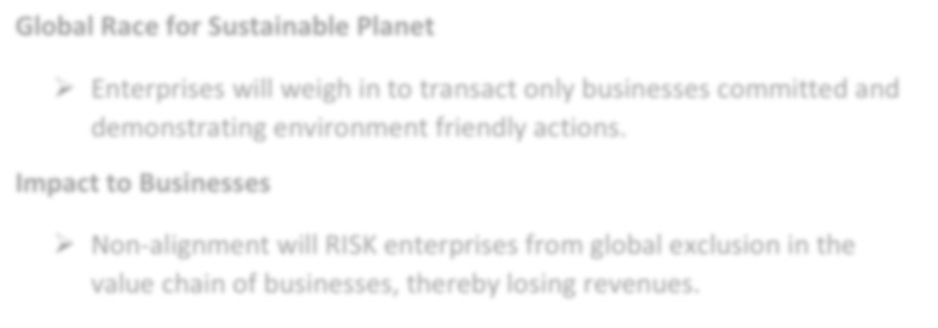

**Global Race for Sustainable Planet**

* Enterprises will weigh in to transact only businesses committed and demonstrating environment friendly actions.

**Impact to Businesses**

* Non-alignment will RISK enterprises from global exclusion in the value chain of businesses, thereby losing revenues.

FIN aims to be the catalyst for accelerating sustainable practices across buildings and businesses. We converge on our block chain enabled platform all stakeholders – Commercial building owners, Small & medium enterprises, Sustainability solution providers, Financiers of green funds and Thought leadership

– offering a ‘one-stop shop’ for all.



**VISION**

FIN’s vision is to accelerate global sustainability initiatives. We aim to do this by converging on our block chain powered platform:

* thought leadership **ecosystem in sustainability** such as strategists, solution providers and assessment companies
* brick and mortar business who **need technology, expertise & funds** to adopt green initiatives to sustain and grow their businesses
* **investors**, retail and institutional, who are seeking lucrative opportunities for wealth creation

An incentive for ‘green enabling behaviors’ - all investors on FIN platform, investing in green initiatives by buildings and businesses, will earn green miles as loyalty credits, which are converted into tokenized Carbon Credits or Renewable Energy Certificates (RECs) and can be monetized in fiat or crypto currencies.

Towards achieving this vision FIN’s operating model would:



**Create** A global community of advisors, solution providers, borrowers and

investors (Delivering speed, ease and convenience)

**Bundle**

Similar projects by consumers (For scale and negotiation

leverage with providers)

**Tokenize** Investments for enabling loans that are fractional,

transferable and accessible to all sizes of investments

**Monetize** Green incentives generated on the platform: unlocking additional monetary value

**Link** To a global ecosystem that offers various opportunities and

solutions on our collective journey to a sustainable planet

Leveraging the benefits of block chain, FIN aims to revolutionize the ecosystem of both – the borrowers and investors, through its platform. We believe that transparency and decentralized nature of block chain offers a unique opportunity for the buyers and investors to have trust and gainful transactions. We believe in the power of block chain to successfully facilitate a frictionless shared economy on our ecosystem due to its ability to:

* + Enable transparency in tracing transactions & records,
  + Eliminate intermediaries,
  + Establish a transparent & trust-based environment,
  + Enhance efficiency through smart contracts.

FIN is leveraging these key features to achieve its vision of accelerating global sustainability through its marketplace. Our ultimate aim is to create an entire sustainability ecosystem globally, that will offer the buyers and investors more incentives to actively engage and support the global green journey.

Democratizing all decisions, FIN empowers all stakeholders listed on its platform to transact directly amongst themselves after duly evaluating their business decisions, without any influence and promotion.



**MISSION**



The cost of being an un-sustainable business is increasing in terms of natural resources such as energy, waste, air and water but more important is the impact on customer sentiment, which is only growing exponentially.

By harnessing leading web3 technology, to effectively bring together technical and financing solutions, FIN’s mission is to be a comprehensive green platform facilitating the sustainability ecosystem and providing one-stop-shop for all Net Zero actions.

**ACCESS to**

**Expertise & Technology**

**ACCESS**

**To Funds**

Search & find the right solutions for your enterprise:

* + - Advisors



* + - Rating agencies
    - Auditors
    - Solution providers(renewable energy, water, waste, air)

Explore financing from a wide range of options provided by various financiers on our platform

* + - Investment banks / Mutual funds
    - HNIs
    - P2P Platforms
    - AIFs
    - Fund & Family houses

As the world’s first Sustainability Marketplace, our mission is to bring together all stakeholders in the global sustainability journey to converge into a shared economy, and embrace sustainable business practices effectively, profitably and rewardingly.



**METHODOLOGY**

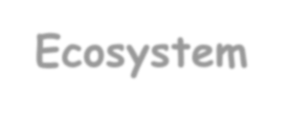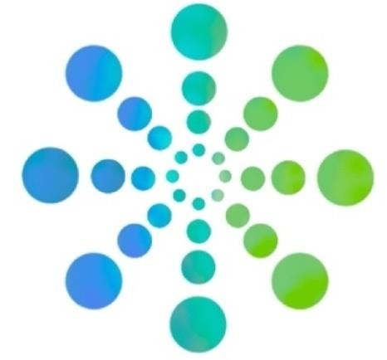

**Sustainability**

**Ecosystem**

**Green Solutions**

**Rewarding**

**Augmenting**

**ESG Goals**

## Sustainability Ecosystem:



**Financing**

Establish an all-encompassing marketplace including Thought leaders, Consumers,

Service providers and Financiers, facilitating a ‘one-stop shop’.

## Green Solutions:



While we believe in a democratic process so you can choose from platform directly, we are equally committed to work with you to find the best solutions for your business and connect with the right partners. As an aggregator platform, we can support with providing scale to your needs by bundling with similar opportunities and allowing leverage for negotiations. FIN will not have any contractual liability on the

Service contracts between the Consumer and Solution Provider or any terms agreed between these parties.

## Augmenting:



For organizations committed to ESG targets, reducing scope 3 emissions is also a key factor. All you would be required to do is introduce your suppliers to FIN’s marketplace and we can support them in achieving their green goals. Effectively organizations will be able to manage sustainable practices across the business ecosystem by actively utilizing our marketplace.

## Financing:



A vital component in driving green practices is funding, which is also a big challenge for Commercial buildings and SMEs who stand the risk of slowing down or unable to implement their plans due to paucity of funds. FIN’s ecosystem has financing companies / individuals who are committed to global climate action goals and willing to fund green initiatives. FIN will not have any contractual liability on the service contracts between the Borrower and Financier or any terms agreed between these parties.

## Rewarding:



FIN would reward the financial investors with loyalty green credits, which can be converted into Carbon Credits and/or Renewable Energy Certificates (RECs). These can be monetized on carbon credit trading exchanges. FIN would also support operating as an aggregator of Carbon Credits and broker on behalf of our clients, if appointed through a separate contract.

As a reward for the businesses who have implemented green initiatives, we would showcase their avoidance and improvement in green scores to their customers, employees and stakeholders. We would equally showcase your efforts in enabling sustainable business practices for your suppliers too.

In summary, we believe it is everyone’s responsibility to regenerate our planet and

reward doing what is right.

We want to create a momentum to accelerate it by facilitating a Sustainability Marketplace.

**BENEFITS**

* 1. Global digital platform, underpinned by block chain technology, to connect consumers with solutions and finances.
  2. Robust research and thought leadership in a rapidly evolving domain so our customers can have access to information readily.
  3. Unique in its approach, of incentivizing investors with encashable green credits.
  4. Investment opportunities to diversify risk and gain returns.
  5. Fractionalised investment for accessibility and flexibility.
  6. First of its kind, allowing investors to trade their green credits, in fiat and crypto currencies.
  7. The holistic ecosystem with a strong network of partners.



**TOKEN OVERVIEW**

## 1.



**NFT: Digital Investment Certificate**

NFT acts as a proof or investment and right to returns on the investment. These will be in effect for the duration of the investment plan and automatically lapse post that. Smart contracts will include these terms.

## 2.



**NFTs: Sales Deed**

Unique NFT# will be generated for all property owners against their sale deeds, at a nominal cost. This is futuristic in the thought with the vision that in near future global transitions can be facilitated by these unique NFT# as a verification tool for ownership and viewing all transactions.

## 3. FIN Token: Utility Token

Reward system to incentivize investors for participation on our platform. These tokens can be encashed in various exchanges in fiat and crypto currencies, based on investor’s choice. These will be available to the investor longer than the investment period but will have an expiry date.

## 4.



**Green Marketplace:**

Buying, selling, exchanging of FIN token, earned through loyalty points on green investments. FIN will establish an ecosystem which will enable transactions of green credits.

FIN token is intended as a utility token and not a security token. It offers access to its ecosystem for facilitating trading in Carbon Credits or RECs in fiat or crypto currencies. FIN token will be listed on various exchange and trading platforms alongside being traded on FIN platform to ensure the community has a wide range of options. As described earlier, FIN incentive system is for only earning

green credits which can be traded independently or through FIN’s ecosystem

based on investors choice.

FIN token is a multi- utility token with a limited release of 1 million tokens which will be used as a medium for incentivizing active investors on FIN platform. The only purpose of the FIN token is to be trade it as an offset for Carbon Credits and/or RECs. FIN does not guarantee revenue returns to its investors for the incentive awarded, while it will endeavor to create an ecosystem that would support trading green credits. FIN and/or FIN token does not in any way represent shareholding participation, rights, title, interest in the company, their distributors, respective affiliates or any other company, enterprise or undertaking, nor will FIN token entitle its incentive token holders to any promise of fees, dividends, revenue, profits or investment returns, and not intended to constitute securities in any jurisdiction. FIN token may only be utilized on FIN platform and/or its partnership platforms and ownership of FIN token carries no right express or implied, other than the right use of the FIN token tokens as a means to enable exchange in fiat or crypto currencies towards Carbon Offsets or RECs.

FIN token provides economic incentives which will be distributed to encourage efforts towards contribution and participation in the ecosystem on the platform, thereby creating a mutually beneficial system where every investor is fairly compensated for his/her valuable contributions.



In a nutshell,

NFTs will secure investments through a smart contract and unique NFT# which

will ensure there is no over-leverage of the project they are investing and thereby protecting their investments.

Flexibility on encashing green credits in fiat or crypto.

Paperless and security in perpetuity for property owners by NFTs for their

sale deeds.



**MARKETPLACE**

The investors will earn incentives through FIN token by adopting, investing and helping scale this offering globally. FIN will offer a marketplace that will enable token holders to engage with potential buyers of green credits to offset their respective carbon footprints. Where these transactions are fungible, the community of investors and buyers will be able to use FIN token to access these green credits within the ecosystem.

Where the experiences are individual, the investors will get NFTs for their investments on FIN platform. The marketplace will offer transactions between borrower and investors with ease, simplicity, efficiency on our block chain powered platform. These NFTs have unique assignments that make them distinguishable. This allows for absolute safety and de-risks investors from their investment being attached multiple times and provides transparency to the investor to track their investments. FIN does not allow a secondary marketplace for these NFTs. These would be consumed only by the investor and expire at the end of the investment duration.

**FIN TOKENOMICS**

FIN aims to mint 1 million green tokens towards incentives and this would be done in a phased manner. These are called FIN token, which are primarily Utility Tokens, and would be purposed as follows:

25% of the FIN token, utility tokens, are reserved for investors, investing in the green projects on FIN platform. This amounts to 25 million (2.5crores) tokens are reserved for loyalty points to the financiers into green projects.

Remaining 75% tokens, 75million (7.5 crores) are available for sale by FIN, which will be further executed as follows. These are anticipatory Green Credits and would be available for encashing in fiat or crypto currencies, once FIN successfully concludes green project transactions on its platform, which would be the trigger for releasing the tokens for sale.

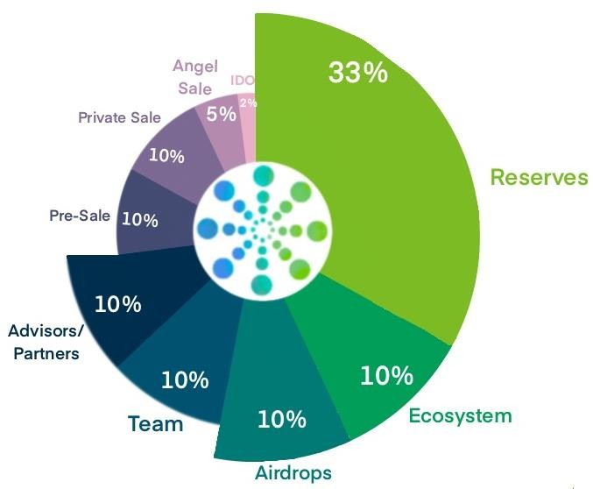



At IDO stage, 2% of these utility tokens, i.e., 1.5million will be issued at US$ 0.10.



During the Angel Sale, 5%, i.e., 3.75million of utility tokens will be processed at

US$0.04 for interested collaborators. This round is aimed at raising funds to progress the development of ecosystem and attain scalability. In this phase 5% of the total supply of FIN coin utility tokens (anticipatory green credits) will be issued.



In this phase, 10%, i.e., 7.5million of utility tokens will be processed at US$0.07 for

interested collaborators.



The pre-sale issuance will include 10%, i.e., 7.5million of utility tokens will be

processed at US$ 0.09.

To gain from valuable insights of experts in the industry, FIN would be working closely with some of these thought leaders as advisors and establish strategic partners to augment its capability. These relationships would be rewarded with 10% of the utility tokens, i.e., 7.5million. The processing value would have the same approach as for the team, which is based basically establishing the date of engagement on FIN’s roadmap.



To attract and retain best talent, 10% utility tokens are allocated as incentives. This

would translate to 7.5million of utility tokens will be processed at a price point based on hiring timelines in the entity’s journey. For example, an employee at Angel Sale would have a value of US$0.04 per token and an employee joining at IDO stage would have a value of US$ 0.10 per token.



Retaining 10% towards air-drops to increase social media engagement and

awareness in the relevant markets. This is 7.5million of utility tokens, processed at US$0.04 for interested collaborators.



10% of the utility tokens, i.e., 7.5million. The processing value would have the same

approach as for the team, which is based basically establishing the date of engagement on FIN’s roadmap.



FIN will hold 33%, i.e., 24.75million as reserve utility tokens with no locking.

**TECHNOLOGY**

Unique in our approach of combining Web2 & Web3

Key Benefits include:

•



**Web Deep Links:**

Multi-tenant architecture with an analytics layer and integrated content library. Pre- defined contracts.

•



**User Interface:**

Robust workflow capabilities enabling simple & seamless user interface, execution and value transfer.



* **Networked API**:

Flexible services enabling integration with other platforms for adjacency solutions.

Web3 is purely used by FIN admin for data management to ensure safety,

immutability and easy access for servicing clients

In the larger block chain architecture, these transactions are happening all the time with robust workflow and automations:

* Pre-defined contracts
* Events
* Execute & value transfer
* Settlement
* Unlimited database customization



**MARKET OPPORTUNITIES**

**US $10B**

300msft Retrofits

@US $25 to 40 per sq. ft.

# US $100M

40msft

New Assets yoy

@US $25 to 40 per sft

**US $5M**

Few Competitors



Most are into consulting solutions; evidenced only one primary competitor in similar domain but focussing mainly on energy sector and not a holistic sustainability platform like ours.



**COMPETITORS**



**FIN**

* Integrated ecosystem for

sustainability projects.

* Extensive knowledge of Real Estate and Operations.
* Productive network.



**Competitors**

* Very nascent stages and evidenced only one operational competitor
* Decarb Earth:
  + Approx. 2 years old with operations in

South Africa.

* + Mainly focussed on energy sector for Real Estate.
  + Doesn’t have an ecosystem.
* Sustainability Consultants:
  + Fragmented and dispersed.
  + Solutions are in silos.



**GO TO MARKET PLAN**

# Awareness:

* Social media
* Strategic partnerships
* Peer to Peer marketing
* Sales networks
* Digital marketing
* Media and Ads



**USE OF FUNDS**

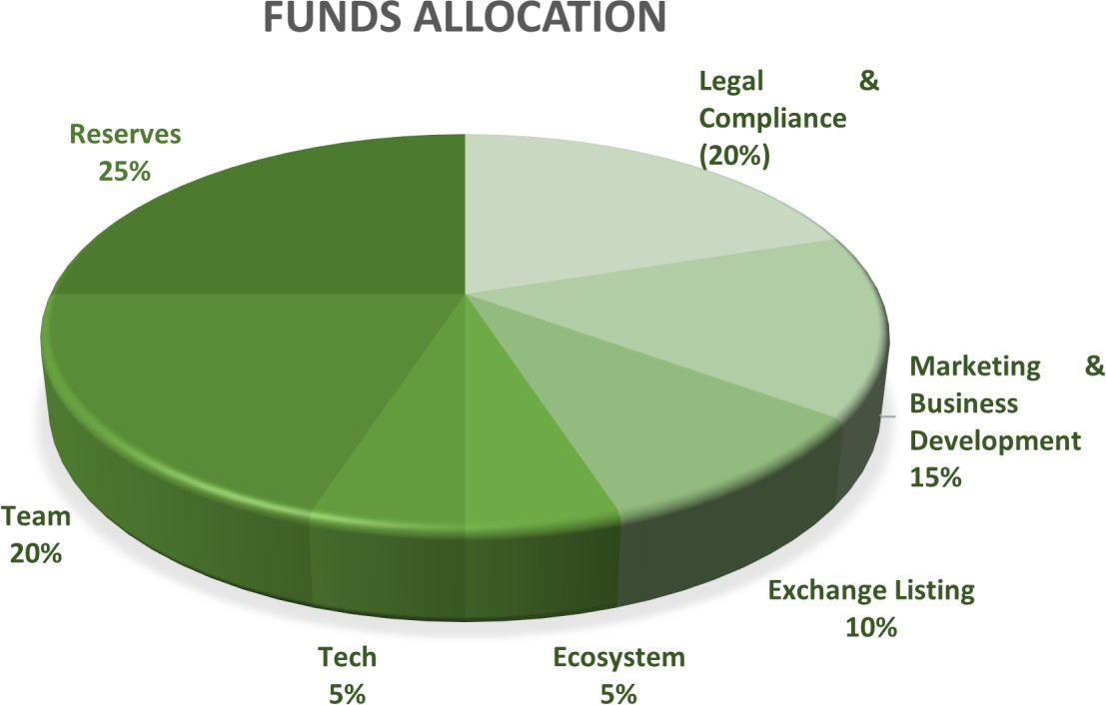

Balancing growth and sustainable business model with value and transparency for the investors in FIN platform, we propose to utilize the funds as follows:

* 10% of the funds will be used to list on exchanges dealing with Carbon Credit offsets and RECs. We will also work towards making meaningful connections with respect to listing the token on variety of CEX / DEX.
* 5% of the funds will be spent for strengthening technology infrastructure for FIN platform and FIN token.
* 15% of the funds will be utilized for marketing and business development. Our marketing plan is detailed in the following section for reference.
* 20% will be reserved for legal and regulatory expenses. Given that our innovative and market leading offering does not have a precedence as yet, we anticipate some headwinds as laws will get drafted, tested, fructified and implemented over the next few years. So higher allocation of funds in the initial years is a prudent effort on our part.
* 20% of the funds will be spent towards expanding the team and cost of salaries.
* 5% will be utilized to manage the ecosystem.
* 25% will be retained as reserves as we grow the platform globally.



**BUSINESS CASE - REAL ESTATE**

Socio economic progress and rise in middle class aspirations has led to significant growth in



**APPENDICES:**

the Real Estate sector. Statistics show that the real estate sector has been growing at a CAGR of 25%+ yoy, and is expected to continue so for many more decades.

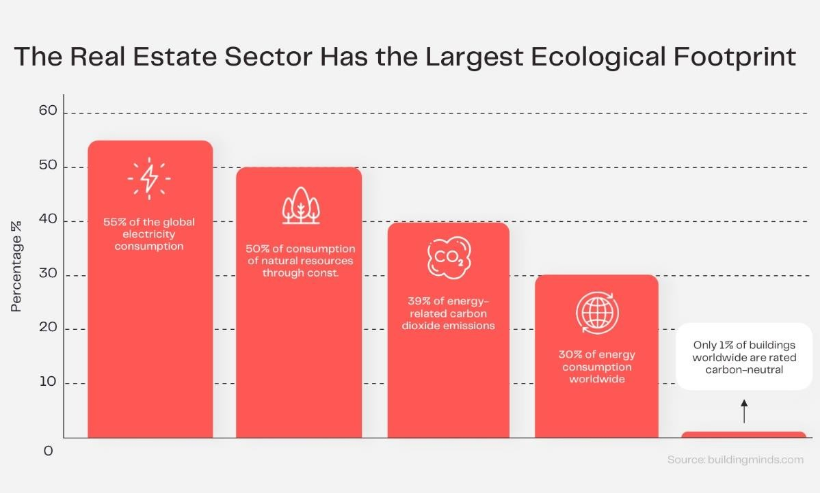

Globally, real estate contributes upwards of 50% of the total greenhouse gas emissions. Hence the focus on real estate to make course corrections and implement sustainable practices if very high. With state rules getting more stringent, and businesses pivoting green completely, real estate developers and small scale businesses will stand to lose their clients if they are not delivering on the sustainability targets, commiserate to their share. It is also a recognized factor that real estate and MSMEs, struggle to secure funds from formal banking channels due to various factors.

Just for India alone, the estimated funds requirement for achieving 2030 COP21 targets is

US$ 20 billion yoy till 2030.

(https://economictimes.indiatimes.com/industry/renewables/india-needs-20-bn-annual-investments-to-achieve- climate-targets-report/articleshow/90168543.cms )

On the other hand, household investments in India have risen to US$ 1.7 trillion in 2021 and is expected to grow at 9.6% (as per IFC report – details to be included). If 5-6% of these household investments are diverted towards the required green investments, India would achieve its sustainability goals.



**REAL ESTATE & THE ENVIRONMENT**

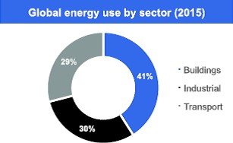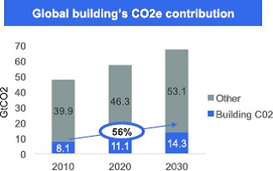

In a rapidly urbanizing world, the real estate industry lies at the center of an unprecedented level of growth and activity.

The real estate sector consumes annually over 40% of global energy, that buildings originate 20% of global greenhouse gas emission, and use c. 40% of raw materials respectively stated by the World Economic Forum states in their report ["Environmental Sustainability Principles](https://www.weforum.org/whitepapers/environmental-sustainability-principles-for-the-real-estate-industry) [for the Real Estate Industry",](https://www.weforum.org/whitepapers/environmental-sustainability-principles-for-the-real-estate-industry)

In the long run, real estate remains an attractive asset as compared to other investments owing to lower risk and better returns, and sustainable real estate will command a premium. Governments, investors, and the public have become increasingly committed to reaching net-zero emissions by 2050. This ambition intends to mitigate the worst potential effects of climate change by limiting warming to 1.5˚ C above pre-industrial levels. Policies to achieve net zero that impact the real estate sector include rising carbon prices, building and energy efficiency standards, and renewable energy mandates. High carbon prices can translate into higher energy costs and increased operating expenses for real assets.

The real estate sector uses more energy than any other sector and is a growing contributor to CO2 emissions. Although measurement is complex, most estimates suggest that the real estate sector is the single most significant sectors in terms of CO2e1 contributions. – The sector consumes over 40% of global energy annually – 20% of total global greenhouse gas emissions originate from buildings – There is a projected 56% increase in building CO2 emissions by 2030 – A 7% increase in proportionate share of global GHG emissions is expected by 2030 – Buildings use 40% of raw materials globally (3 billion tons annually) Buildings also have a significant and growing impact on other environmental aspects. For example, by 2030 buildings are expected to use 12% of global fresh water, and generate 30% of total waste in the European Union.



**GREEN BUILDINGS**

There has been a significant shift towards the production of “more environmentally sustainable buildings. Currently, 40-48% of new commercial builds are “green”, compared to only 2% in 2005. Of course, the majority of the world’s real estate stock is already in existence, and it is harder to achieve environmental improvements. Nonetheless, there has been a parallel growth in retrofitting to produce greener properties as survey results show, client and market demand are important drivers, while lower operating costs and branding/PR are now the two biggest factors influencing green building investment decisions. Typically, green building activities lag behind changing regulatory requirements Management and reporting of environmental data in the sector has improved alongside overall performance. The GRESB (Global Real Estate Sustainability Benchmark) survey assesses the environmental, social and governance (ESG) performance of 707 property companies and private equity real estate funds that represent 61,000 assets and $2.3 trillion in asset value. Recent results show that: – 288 out of 707 property companies and funds have long-term carbon reduction targets – The average reduction target is a 21% decrease in carbon emissions over a period of 7 years10 – 37 companies and funds have reduction targets of 50%(or more), over an average period of 13 years – Short-term reduction targets (for one year) are in place for 247 companies and funds, with an average reduction target of 7% – However, 28% of the 707 property and companies and funds reporting to GRESB in 2015 did not provide data on the environmental performance of their real estate.

(<https://www.un.org/sustainabledevelopment/sustainable-development-goals/>)

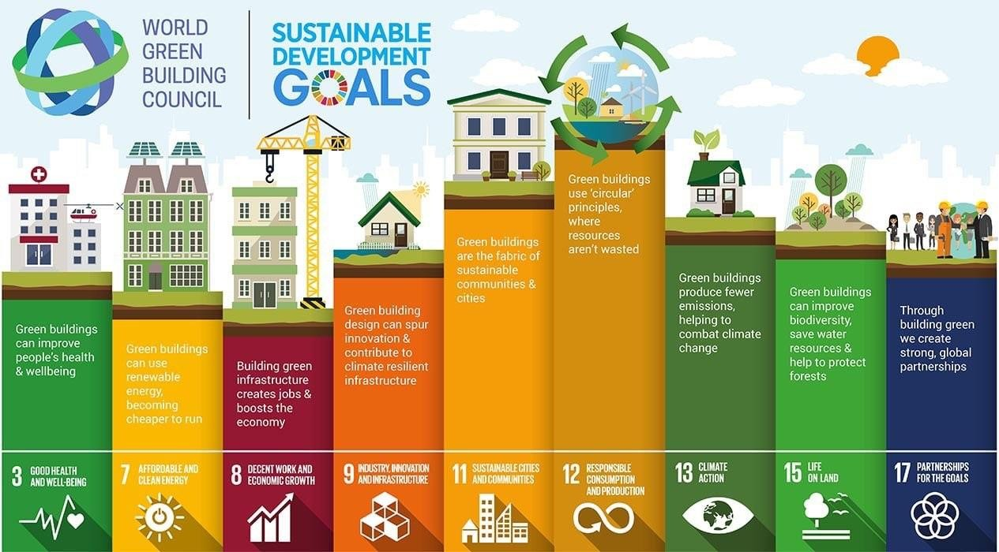

A recent study by Dell surveyed 4600 business leaders in 42 countries to determine the current state of digital transformation efforts. Only 5% of the businesses surveyed were categorized as ‘Digital Leaders’.

Historically, the Real Estate sector has been a laggard in adopting technologies, and sustainability will become a pivot to leap frog into modern technologies of Blockchain, NFTs and Crypto to transform from centralized to de-centralized ledger systems.



**BUSINESS CASE –**

**SMALL & MEDIUM ENTERPRISES**

[Small and medium sized enterprises](https://www.sciencedirect.com/topics/economics-econometrics-and-finance/sme) (SMEs) play an important role in any economy as they contribute to GDP and employment. However, sustainability (right combination of economic, environmental and social) of SMEs is a major concern as they prioritize economic performance over environmental and social to remain competitive. Majority of prior researches on SMEs' sustainability either look at the impact of a few limited enablers (e.g., lean, green, innovation etc.) on sustainability performance or the effect of pressures and barriers on the sustainability performance. There is a clear gap of a holistic and robust framework for sustainability performance analysis in order to measure and improve sustainability performance.

Real estate often accounts for a large part of the assets and value of a company. In this respect, they are also of great importance in the valuation of SMEs.

Against the backdrop of the [Coronavirus](https://www.business-standard.com/about/what-is-coronavirus) (Covid-19) pandemic and its aftermath, small and medium enterprises (SMEs) will lead asset-quality deterioration, particularly for countries like Turkey, South Africa, India, China, Indonesia, and Thailand. Stress in Indian [SMEs](https://www.business-standard.com/topic/smes) is somewhat tempered by the government's guarantee of new loans taken by SMEs, up to 20 per cent of their aggregate loans, thereby easing liquidity pressure for [SMEs](https://www.business-standard.com/topic/smes).

In China, total exposure to SMEs is small but has risen rapidly in the past few years as the government encouraged lending to this segment. Russian banks have manageable exposure to SME-related risk since large and mid-size businesses dominate the economy.

The Covid-19 pandemic and its aftermath will continue to dominate the credit story for emerging markets in 2021.

In India, many real estate companies are suffering from a combination of low sales velocity and weak prices, which may mean that a few companies will resort to restructuring their debt.

A landmark 2011 study from American Express OPEN Independent Retail Index revealed that successful small businesses could help bolster sagging real estate markets in some communities. The study found that over 14 years, neighbourhoods with thriving independent businesses saw home values outperform citywide markets by 50 per cent.

While this study isn’t recent, it shows what businesses and communities have always known: Small businesses are a community’s lifeblood. Researchers aimed to show how communities that support independent shops reap benefits, including higher real estate values and more local jobs.

It’s important to note that the relationship between real estate and SMBs is cyclical. Small businesses dominate the country’s trillion-dollar real estate sector. That’s not true for any other U.S. industry of its size. So, when small businesses slump, local real estate often does as well.

Small and medium enterprises (SMEs) are a noteworthy driver of economic development. Being vital to most economies across the world, particularly in developing and emerging nations, they represent 99% of all businesses in the European Union (EU) and in the last five years, provided about 85% of new jobs, also ensuring two-thirds of the total private sector engagement in the region. For instance, in 2015, there were about 23 million SMEs that provided 90 million jobs, generating a higher added value of 3.9 billion EUR. Different to large corporations, SMEs are highly flexible, revealing a superior flexibility to technical shifts, higher promotion of income distribution and better adaptability to fluctuations in the market and new customer requirements, while their organizational structure allows for quicker decision making. Nevertheless, to achieve this potential, SMEs need a continued source of longstanding funding so as to invest in growth opportunities. Hence, wishing to strengthen the entrepreneurial spirit in Europe and to create conditions for the practical development of innovative concepts, the European Commission designed a set of measures alongside a modern and coherent policy for SMEs.

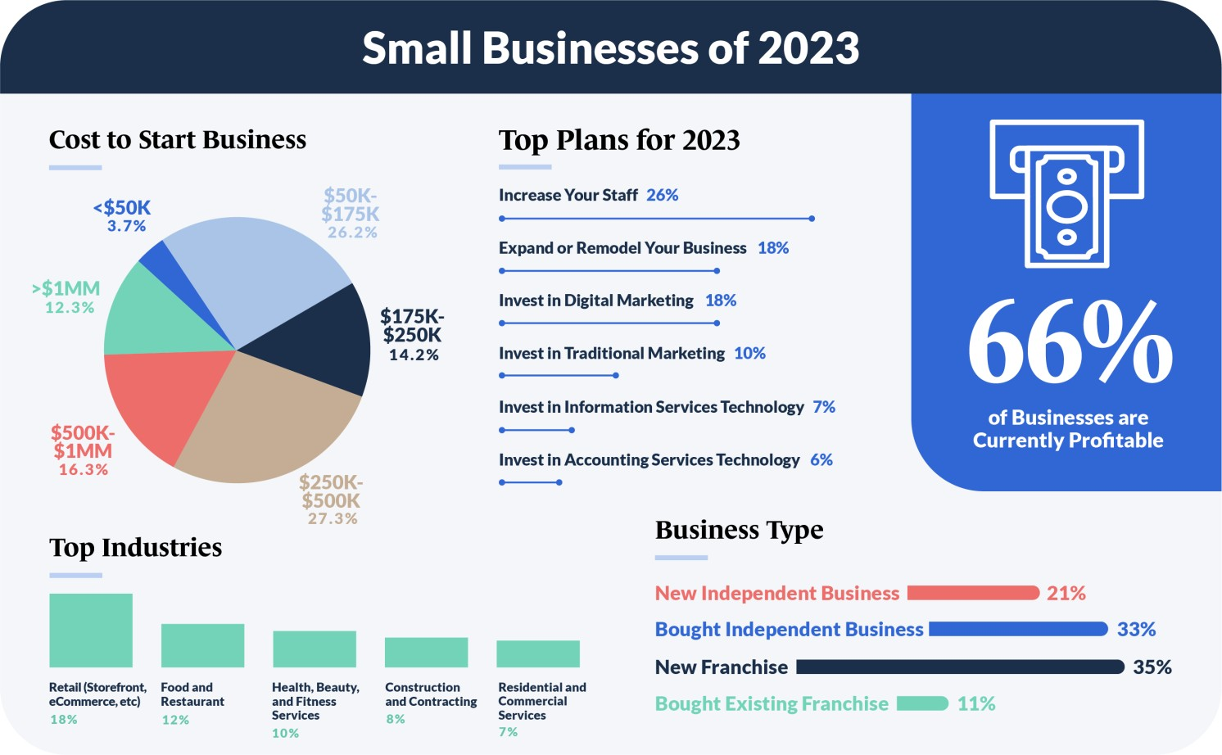

<https://www.guidantfinancial.com/small-business-trends/>